**Transfer the figure into your notebook and complete it to form a parallelogram. Solve this.**

ChatGPT

To complete the figure and solve it, I will analyze the diagram.

The two parts (a) and (b) of the figure seem to represent half-completed parallelograms, given the diagonal lines in each image. Here's how you can proceed:

**Step-by-Step Approach:**

**Part (a):**

1. The points given are A, B, and C.
2. The dashed line from A likely indicates another vertex of the parallelogram.
3. To complete the parallelogram, you can draw a line from point C parallel to the line AB and extend it to meet the dashed line. This will give you the fourth vertex, say D.

**Part (b):**

1. The points given are B and D, along with the dashed line starting from B.
2. Similar to part (a), you need to extend a line from D parallel to the dashed line from B to form the other side of the parallelogram. The intersection point will give you the final vertex, say C.

Once both figures are completed, check if the opposite sides are parallel, ensuring the shape is a parallelogram.

If you need a visual representation or further steps, I can help you better visualize the solution. Let me know how you'd like to proceed.  
  
**Transfer the figure into your notebook and complete it to form a parallelogram. Objective: Pupils will learn how to form a parallelogram.**

Here is the diagram with two incomplete figures, which can be completed into parallelograms by drawing lines parallel to the existing sides. You can use this visual to guide pupils in forming a parallelogram by ensuring the opposite sides are parallel and equal in length.  
  
**Transfer the figure into your notebook and complete it to form a parallelogram. If you know you need to use the compass to draw two arcs that intersect at two points. Then, use the scale to connect the points of intersection. Finally, use the compass to draw two more arcs that intersect at two additional points and connect these points as well, and you will have created a parallelogram, how would you solve this? Draw it.**

ChatGPT

Construction of a Parallelogram Using Compass and Scale

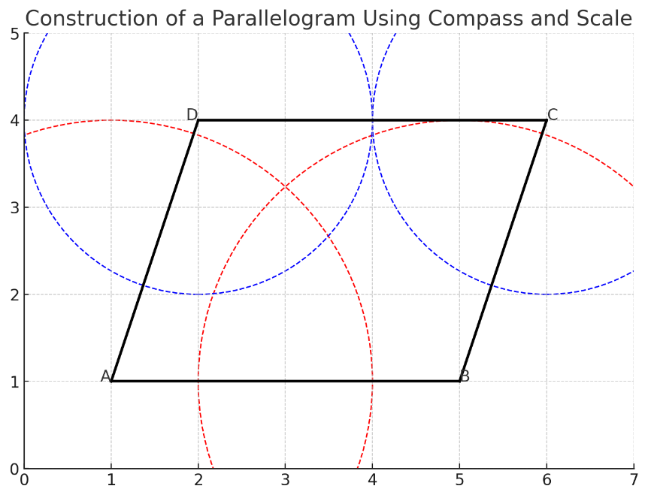

Here is a visual representation of how to construct a parallelogram using a compass and a scale. In this diagram:

* The black lines represent the sides of the parallelogram.
* The dashed red and blue arcs represent the compass arcs drawn from points AAA, BBB, CCC, and DDD to identify the points of intersection.
* Once the arcs intersect, you can use the scale to connect the points, forming the complete parallelogram.

This method demonstrates the geometric approach of drawing and verifying that the opposite sides are parallel and equal in length. ​​

**Transfer the figure into your notebook and complete it to form a parallelogram. To solve this, you need to finish the interrupted lines and non-interrupted, how would you solve this? Draw it.**

ChatGPT

Completed Parallelogram with Interrupted and Non-Interrupted Lines

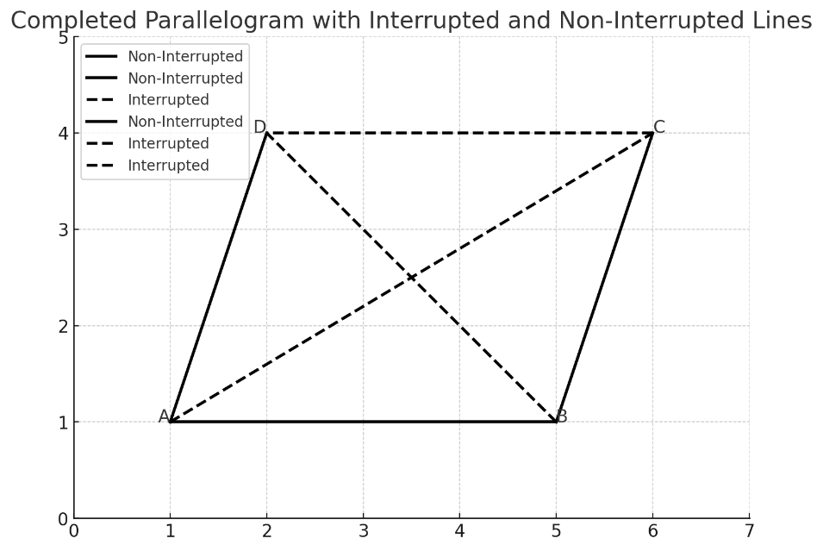

Here is the completed parallelogram with both interrupted and non-interrupted lines. The solid lines represent the non-interrupted sides of the parallelogram, while the dashed lines represent the interrupted or incomplete parts, which have been extended to form the complete shape.

To solve this geometrically:

1. **Non-Interrupted Lines**: These are the sides already drawn.
2. **Interrupted Lines**: These are the diagonal lines and some sides that needed to be completed. By extending them, we ensure that opposite sides are parallel, thus forming the parallelogram.

This approach shows the necessary steps for completing and connecting the lines. ​​

**Transfer the figure into your notebook and complete it to form a parallelogram. Please solve this step by step.**

ChatGPT

To solve this step-by-step and complete the parallelogram, let’s break it down into a structured approach:

**Step 1: Identify Given Points**

You are provided with an incomplete parallelogram figure, with some lines interrupted and some lines non-interrupted. The vertices of the parallelogram are labeled as AAA, BBB, CCC, and DDD.

* **Given points and sides**:
  + Point AAA and Point BBB are connected by a solid line.
  + There are dashed lines indicating the incomplete parts of the parallelogram.

**Step 2: Identify Parallel Sides**

* Opposite sides of a parallelogram are always parallel and equal in length.
* This means we need to complete the missing sides in such a way that the sides opposite to each other (i.e., ABABAB and CDCDCD, ADADAD and BCBCBC) are parallel and equal.

**Step 3: Use a Compass and Scale (Constructing Parallel Lines)**

To complete the parallelogram:

1. **Draw an arc from point AAA** using a compass. This arc should cross where the missing side of the parallelogram is expected to be.
2. **Draw a similar arc from point BBB** to the same length (this ensures the side will be parallel and of equal length).
3. **Intersect the arcs**. Now, connect these intersecting points using a straightedge to form the other sides of the parallelogram.

**Step 4: Completing the Diagonals**

* Parallelograms have diagonals that bisect each other.
* Draw the diagonals ACACAC and BDBDBD by connecting these points using a ruler.

**Step 5: Final Check**

* Ensure that opposite sides are equal and parallel, and the diagonals bisect each other.

**Visual Diagram**

I will now re-plot the final completed parallelogram with all steps represented visually.

Step-by-Step Completed Parallelogram

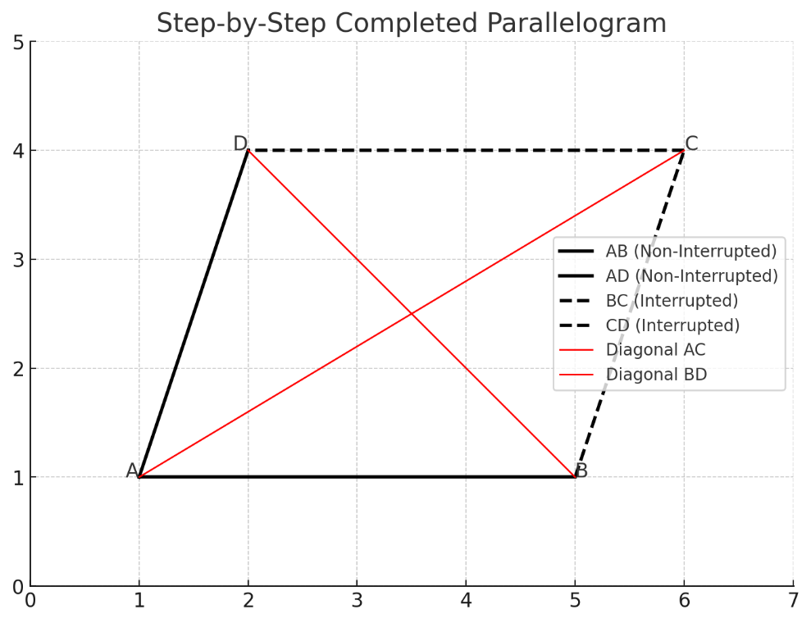

Here is the step-by-step construction of the parallelogram:

1. **Non-Interrupted Sides**: The lines ABABAB and ADADAD are solid and already drawn.
2. **Interrupted Sides**: The dashed lines represent the incomplete sides, BCBCBC and CDCDCD, which need to be drawn to complete the parallelogram.
3. **Diagonals**: The red lines represent the diagonals ACACAC and BDBDBD. These diagonals bisect each other, confirming the structure is a parallelogram.

By connecting the interrupted lines, we form the completed parallelogram with all properties intact. ​​